Egor Philippov – 100114734 CMPT 365
Darius Yao
Project Report
For our group project we have decided to create a photo editing software. Our influences came from a Photoshop/Paint-like program by the name of Irfanview ( http://www.irfanview.ca/ ). The development of this program was done primarily in Visual Studio 2010 and written in C#. Our program has many simple features and our most notable highlights include rotation at an angle, red eye reduction and the stitching of multiple images to a panoramic view.
As the name of the program suggests, the purpose of this application is to provide the user with the means to browse through and do some minor adjustments of his/her photos. It is important to note that photographs, usually exported from a digital camera, are stored in the same directory and it is thus important to implement some sort of built in browsing capability. In addition, as photo browsing is a purely visual experience, it is important to implement certain UI features to ease the task. Most of the advanced features, which will be covered later, provide an original image and a preview of the modified image. Also most of the more complex features come with a scroll bar, which should make making desired modifications to an image a breeze.
Firstly, it is worth mentioning the basic features of our photo viewer. When the program is first loaded, most of the menus will be grayed out and the toolbar icons will be unresponsive. Once the first image is loaded, the full functionality of the program is unlocked. As the purpose of this program is to help the user manage his/her photos, after the initial image file is loaded, the user will be allowed to easily click and transition through all the images in that file's directory. The user will be able to perform the most basic operations like open, delete, save, save as and reopen, which can be found under the "File" menu. If the user decides to make changes to his/her photo they may find the available functions under the "Image" menu. The functionality allows for rotation in any direction ( in increments of 90 degrees or at any angle in a separate form ), vertical and horizontal flipping, resizing ( preserve aspect ratio option available ), cropping, conversion to grayscale, conversion to negative, color adjustment ( any of the RGB channels, brightness, contrast, gamma and saturation ), red eye reduction and finally panoramic stitching. To accommodate the user in cropping and red eye reduction, a rectangle selection tool is implemented to help the user select a portion of the image. As the visuals are the main focus of this program, most features comes with a preview of the image. To allow the user to more easily view his/her photos, additional functionality is available under the "View" menu. Here the user may navigate through the files in the current images directory, zoom in and zoom out.
The first highlight of our program is the functionality that allows the user to rotate an image at any angle from 0 to 360 degrees. The idea here is very easy to describe and visualize, but is not trivial to implement. Our image can be thought of as a matrix of pixels and upon rotation these pixels have to be shifted to some other location. Now we did not have to implement the rotation of the actual pixel as C# conveniently has a build in matrix class that can do this. This matrix is even integrated into the graphics object that we work with, so the actual rotation is fairly trivial to do. However, the matrix is not rotated around middle, but instead it rotates by its upper left corner. To make the matrix rotated around center, it must first be translated down by half its height, then to the right by half its width, rotated and finally moved back to its original position. This procedure will produce an output that may seem satisfactory to most users, but unfortunately there is a problem as can bee seen in the picture bellow:
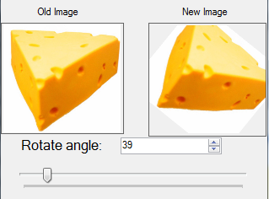
It can be seen here that as the image is rotated, the image size is preserved and thus some clipping occurs. As a consequence of rotating an image, its boundaries must change. This problem can be solved using basic trigonometry. The rotating of an image will result in 4 right angle triangles, one in each corner of the bounding image. The width of the bounding image can be represented as the width of the two bottom ( or top ) of these triangles and the height being the height of two leftmost ( or rightmost ) of these triangles. This can be portrayed more easily in the following image:
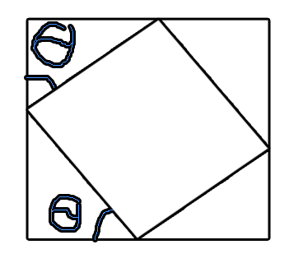
Therefore the height of the bounding image is equal to “sin(angle)*width of rotated image+cos(angle)*height of rotated image”, while the width of the bounding image is equal to “ cos(angle)*width of rotated image+sin(angle)*height of rotated image”. This is almost the complete solution to the clipping problem; however, we also have to take into account in our formula the position of the width and height sides of the rotating image. Basically, every 90 degrees the rotating image's width and height switch places. After taking this into account and implementing the above formulas for the width and heights of the bounding image I was able to achieve a correct solution with no clipping:
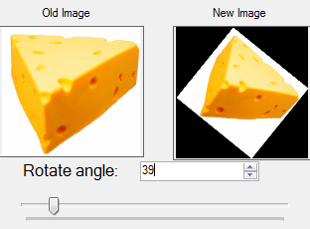
As can be seen from the above image ( better portrayed when running the actual program ), the size of the bounding image are changing at every new angle to make the image fit without any clipping.
The second highlight of our program is the red eye reduction. However, before implementing this feature we had to implement a rectangle selection tool. This type of tool can be seen in many types of applications where a rectangle ( borders are usually represented by dotted/dashed lines ) is drawn on top of the image as the user clicks and drags his/her mouse across the screen. To implement this tool, we had to use a variety of different form events and invisible objects. At first we capture when the mouse is pressed down and proceed to draw the rectangle as it is dragged until the mouse is released. Then we create four invisible rectangles with a very small width along the boundaries of this rectangle to aid in stretching the selection. The “mouse down” event handler is then used to check whether the user clicks outside the selection rectangle ( clear the selection ), inside the selection rectangle ( move on drag ) or on the invisible rectangles ( stretch selection on drag ). The “mouse hover” event is then used to change mouse pointer icons to indicate to the user the type of action they are going to do to the selection. Additional special cases are implemented that are not worth going over, but can be seen in the code ( ex. selection must not go outside of the boundaries of the image or any subsequent action involving the selection will crash the program ).
After implementing the selection tool, we were then able to implement the red eye reduction functionality ( a long with image cropping ). There are really only two ways to do red eye reduction. On one hand, you can make the reduction “global” which requires no selection; however, the algorithm must scan the entire image to find faces, find the eyes and then scan the skin color to reduce the red by a proportional amount. On the other hand you can ask the user to select the area of the face with the red eye and apply the reduction to every single pixel. We chose the second way as the first may be outside the scope of this course. Our algorithm will scan all the pixels in the rectangle selection and determine if they are “too red”, if they are then make them not red ( do note that a pixel that appears red will have a higher value for its red channel than for its green and blue channels ). To find the red pixels we take the red value of the pixel and divide it by the average of the green and blue. If the resulting value is greater than the magic number of 2.0, then the red value is replaced by the average, otherwise it is skipped over. Replacing the red value with the average of the green and blue values preserves the natural glow of the eyes and keeps the image looking realistic. The recommended magic value for the red to green/blue ratio is 1.5, but there is a trade off. If we choose a value that is too high then some ( or even all! ) of the redness of the eye may be looked over. If on the other hand we select a value that is too low, our algorithm may recolor the wrong parts of the selection, which may lead to discolored hair, lips, etc... An example of the red eye reduction can be seen bellow:
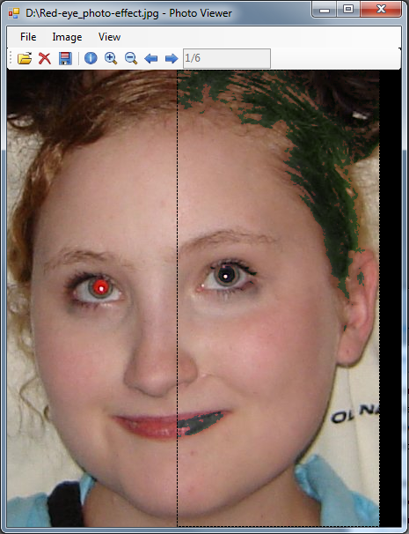
Note that here we have selected a big ( too big ) selection of the person's face and thus some pixels that were too red, got processed. This picture illustrates the downside of this algorithm. However, it still works exceptionally well if the user takes the time to select the face.
The panoramic stitching process requires a combination of several mathematical processes. Pictures are first analyzed and a list of points of interest are extracted. Next, the points on different pictures are compared with each other to examine possible correlation. After obtaining a set of correlated points, a homography transformation is used to orient the pictures to fit into each other more smoothly. Finally, a blending algorithm is used to smooth out the large changes in colour intensities that occur when the edges of one image is overlapped over another. The AForge.NET and Accord.NET framework libraries were used to perform these complex procedures. A more detailed explanation of how each procedure is given in the following paragraphs.
The strongest point detecting algorithms available today are SIFT (scale-invariant feature transform) and SURF (speeded up robust feature) which is inspired by SIFT. Point detection algorithms are based on the observation that the edges and especially the corners of objects are susceptible to large intensity variations due to major changes in colour. Due to the complexity of the algorithms, it was difficult to port existing SIFT or SURF code written in C to our C# program. We used an alternative – the Harris corner detector, developed by Chris Harris and Mike Stephens in 1988 – which was written in C# and therefore allowed us to integrate it into our program with less difficulty. The Harris detector considers the partial differentials of points and approximates them using a Taylor expansion. The gradient, or the direction of maximal change, of this approximated function is then used to derive a matrix known as the structure tensor. The eigenvalues of this matrix determines whether the point has a feature of interest – namely, whether it is an edge or a corner.
The correlation function used takes a window of pixels around each interest point on one image and compares it with the window of pixels around all the interest points from the other image. After this round robin comparison, points with maximal correlation are taken as pairs.
In panoramic stitching, we want to simulate a continuous image as if we were immersed in the location of the photograph and turned our head from one side to another. A homography is necessary to do this because we are using discrete pictures taken at different angles. Consider a circle being the person's point of view, and the two images as two tangent lines. Simply merging the pictures generates a triangular perspective, rather than the circular perspective perceived by our eyes, as shown in the picture below.
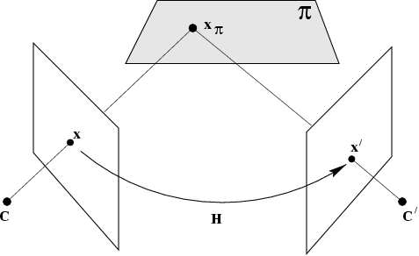
A homography is a matrix that describes the projection transformation causing alterations to observed objects when the oberserver's point of view changes. The method used to obtain the homography matrix in the Accord.NET library we used is RANSAC (random sample consensus).
RANSAC is a mathematical model proposed in 1981 by Fischler and Bolles. It is an iterative method with increasing probability of results depending on the number of iterations. It takes a random subset of the data and assumes they are all inliers and fits a model to it. All points that were not selected are then compared with this model, and if they fit comparatively well to the estimated model, they are included as inliers. The model is then re-estimated taking all the newly included inliers into account, and then the model is tested for its accuracy by examining the error relative to all the inliers used. If the model fails to attain enough data points as inliers the model is rejected. Otherwise, it is accepted and the process repeats for a fixed number of iterations. If a future iteration of this process results in a more accurate model, it will replace the previous model.
The final process is to blend the image together. The blending filter provided by the Accord.NET library uses the homography matrix to merge the two images. A linear alpha gradient is used to compromise the differences between the images, especially at the edges. The gradient is obtained by examining the distance between the centers of the two images.
This project allowed us to learn about some of the more intricate details of image processing. We expected the mathematics involved would be challenging, but understanding the basis from which these complex operations were conceived have been very intriguing. Although the functionality contained in our program is minimal, whenever I open it and perform a little image manipulation, it really feels like a miniature version of Irfanview.

